Thank you for your RSVP! We are excited that you are planning to come. For your convenience we have arranged for you to pay for the Barbecue through Zelle. That is our preferred method of payment.
Registration and Barbeque cost is: $40 for each adult
$15 for each child between 5 and 11 years of age.

Cost covers registration, meal, drinks, supplies, event setup, games and entertainment.

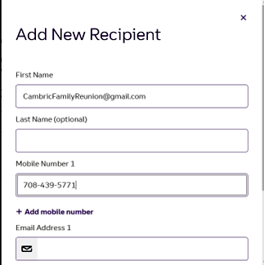
Zelle:
If not already registered for Zelle, download app
Input your information
Select Send
Select Add Recipients or Manage Recipients:
To create contact information:
Add CambricFamilyReunion@gmail.com for first name
Add 708-439-5771 for Mobile number

To Pay
Find and select CambricFamilyReunion@gmail.com in your recipient contact list
Total your payment for all attendees
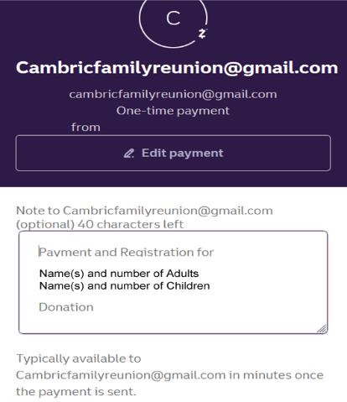
Enter Amount : [Total: (each child and adult you are paying for)]

Select Review Entry
Press what’s this payment for
In Memo area:
(Write out names of each adult/child being covered with this payment)

Note if your payment includes a donation to help with family members that may not be able to afford the registration, please indicate by typing below your group of names
Donation: $ amount

Thank you in advance!
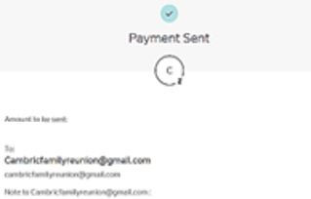
Review and Click Send
All Done!
If paying cash or if you are unable to pay by Zelle please call me at the number listed above after 6pm CST to discuss other forms of payment.
Our webpage www.CambricFamily.com should be up in May
See you in
Chicago August 12!!
Thank you
Sophia Brown
Cambric Family Reunion Treasurer
708.439.5771 (calls accepted after 6 pm CST)

